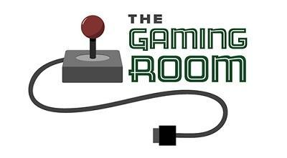

Draw It or Lose It

CS 230 Project Software Design Template
Version 1.0

Table of Contents

CS 230 Project Software Design Template 1
Table of Contents 2
Document Revision History 2
Executive Summary 3
Requirements 3
Design Constraints 3
System Architecture View 3
Domain Model 3
Evaluation 4
Recommendations 5

Document Revision History

Version | Date | Author | Comments
1.0 | 09/19/2026 | Payton Green | Completion of the Executive Summary, Requirements, Design Constraints, and the Domain Model sections
1.1 | 09/29/2026 | Payton Green | Completion of the Evaluation and Recommendations sections

Instructions
Fill in all bracketed information on page one (the cover page), in the Document Revision History table, and below each header. Under each header, remove the bracketed prompt and write your own paragraph response covering the indicated information.

Executive Summary

The Gaming Room wants to develop a web-based game that serves multiple platforms based on their current game, Draw It or Lose It, which is currently available in an Android app only. The Gaming Room has hired Creative Technology Solutions to propose optional solutions to determine the specs required to run Draw It or Lose It on Mac, Windows, Linux, and mobile device web-based systems. The Gaming Room has also hired Creative Technology Solutions to complete the game’s code with the provided requirements described in the next section.

Requirements

- A game will have the ability to have one or more teams involved.
- Each team will have multiple players assigned to it.
- Game and team names must be unique to allow users to check whether a name is in use when choosing a team name.
- Only one instance of the game can exist in memory at any given time. This can be accomplished by creating unique identifiers for each instance of a game, team, or player.

Design Constraints

- Cross platform synchronization
  - Since Draw It or Lose It is a multiplayer game that intends to connect multiple users on multiple platforms all actions within the game must translate to other platforms. As the intended design pattern for the GameService class is a singleton design pattern all actions must be compatible through the GameService instance.
- Network Latency
  - All actions will need to be sent across platforms to each user’s OS. Different platforms are going to perform differently. The implication for this is to implement a server in which every type of platform can communicate and receive data.

System Architecture View

Please note: There is nothing required here for these projects, but this section serves as a reminder that describing the system and subsystem architecture present in the application, including physical components or tiers, may be required for other projects. A logical topology of the communication and storage aspects is also necessary to understand the overall architecture and should be provided.

Domain Model

Entity serves as the base class for the Game, Team, and Player class. Game, Team, and the Player class will have objects referring to the class after them as shown in the diagram (left to right). For GameService it shall hold a list of objects referencing the game class, Game will hold a list of objects referencing the Team class, and Team will hold a list of objects referencing the Player class. GameService is designed to include a singleton design pattern. ProgramDriver uses the SingletonTester class in order to test the creation of a single GameService instance within memory.

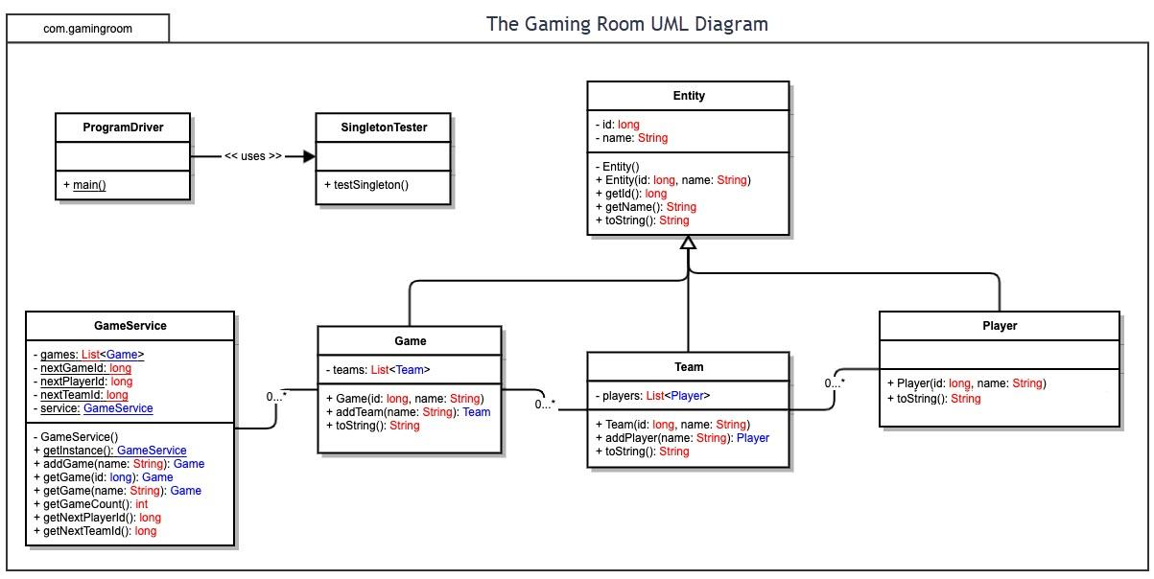

Evaluation

Using your experience to evaluate the characteristics, advantages, and weaknesses of each operating platform (Linux, Mac, and Windows) as well as mobile devices, consider the requirements outlined below and articulate your findings for each. As you complete the table, keep in mind your client’s requirements and look at the situation holistically, as it all has to work together.

In each cell, remove the bracketed prompt and write your own paragraph response covering the indicated information.

Development Requirements | Mac | Linux | Windows | Mobile Devices
Server Side | Untimely background tasks could cause the web-server to lag. Requires third-party configurations to modify and run web-based servers. | The industry standard for web-based servers. Firewalls must be manually implemented and configured. | Requires a Windows Server License. Requires significantly more RAM and CPU to run a web-based server. | Extremely inefficient. Mobile devices don’t have unique public IP addresses making it impossible for users to connect to the server
Client Side | No major requirements for supporting multiple Mac clients. The functionality of the game should support every type of OS input. | No major requirements for supporting multiple Mac clients. The functionality of the game should support every type of OS input. | No major requirements for supporting multiple Mac clients. The functionality of the game should support every type of OS input. | No major requirements for supporting multiple Mac clients. The functionality of the game should support every type of OS input.
Development Tools | Typescript  Javascript  Node.js  Go  Eclipse  Visual Studio | Typescript  Javascript  Node.js  Go  Eclipse  Visual Studio | Typescript  Javascript  Node.js  Go  Eclipse  Visual Studio | Typescript  Javascript  Node.js  Go  Eclipse  Visual Studio

Recommendations

Analyze the characteristics of and techniques specific to various systems architectures and make a recommendation to The Gaming Room. Specifically, address the following:

- Operating Platform: Linux is the industry standard for hosting servers and is recommended for hosting the servers for Draw It or Lose It.

- Operating Systems Architectures: Linux is open-source and requires very little hardware specs to run servers. Linux’s flexibility allows it to be upgraded and expanded as more servers are needed for an expanding player base.

- Storage Management: Linux uses file storage to store everything. This makes it easy to find and identify necessary data.

- Memory Management: Draw It or Lose It will always have only one instance of the game existing in memory.

- Distributed Systems and Networks: Since Draw IT or Lose It is a web-based application clients will connect to the server through HTTP requests. Every OS supports HTTP requests and the linux server will automatically translate the request into JSON. If a user is unexpectedly disconnected from a Linux server, the server will keep running and keep the client connected for a limited time. After that, the server automatically terminates the connection. This does not affect the other clients.

- Security: Client data is stored inside of the server’s database. Linux sets strict file permissions and implements custom firewalls to ensure the protection of data.

